The Detection for Falling

Matthew Gan

March 4, 2021

**Abstract**

This project is currently focusing on detecting falling. The main idea of this project starts with obtaining footages of people falling along with non-falling activities. To analyze the footage and extract features, a tool named “OpenPose” developed by CMU is applied to the footages to obtain the positions of the various parts of the body in each frame. These data will then be fed into a CNN model with labels that indicate if the person is falling in a frame. Unfortunately, the result shows a low accuracy, with extremely high False Positive Rate. The next step would be analyzing the results and try to find the reasons behind the low accuracy.

# Topic and Motivation:

The Topic of this project is detecting the action of falling inside a video and the hope of this project is to allow a smart home monitoring system to detect the falling of a person who may have underlying issue. For example, if a person with underlying medical issue suddenly has a stroke and falls onto the ground, the system would be able to immediately alert surrounding people and send messages to medical staff.

# Related Works:

Given the motivation described above, various studies have already been conducted to try to solve this problem. In 2010, Lai and Huang[1] utilize various sensors, such as neck sensor, waist sensor, and thigh sensor all together to perform a body posture analysis, with the adaptive adjustment model to eventually determine if the person’s posture is during a falling motion. Even as early as 2002, a group of researchers in Spain[2] already developed a distributed intelligent architecture for falling detection, with a similar approach to the previously mentioned study that utilizes body sensors and feeds the data into an algorithm. However, the approach we are taking here focuses on computer vision, coupled with feature analysis and extraction.

# Proposed Model:

This model is my own attempt of utilizing a CNN model to learn detection from data that is composed of body part locations. The Architecture is shown below:

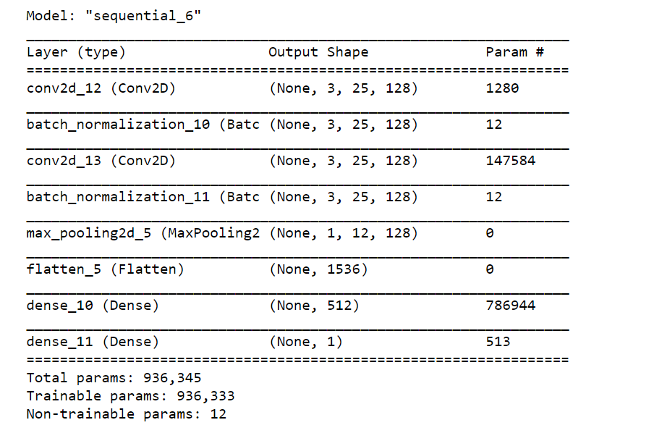

# Dataset

The dataset used for this first attempt is a dataset named “UR Fall Detection Dataset” that comes from the University of Rzeszow. This dataset contains 70 videos, with 30 falls and 40 activities of daily living and each video lasts about 5 minutes. This dataset contains video footages of these activities with two cameras, with one horizontal with the ground and one on the top. However, at this point we will only be using camera 0 that has a horizontal angle view. Link for this dataset: <http://fenix.univ.rzeszow.pl/~mkepski/ds/uf.html>

# Model Training and Performance

As we can see before the model is a CNN model composed of two conv2D layers, two batch normalization layers and two dense layers. Due to small size of dataset, the learning rate is set to be as low as 0.01 and the kernel size to be 3. Given this is the first attempt, the next step would be optimizing these hyper-parameters with larger dataset. Also due to the same reason, I only train the model with 50 epochs and I actually notice an over-fitting already. The performance on validation is similar to training, with relatively low accuracy. Based on the figure below, we notice this model is performing pretty poorly and thus we need to improve it much more to make it practical.

# Performance on Youtube Videos

To apply this model to an actual video, a similar approach as the training approach would apply here. The youtube video would be first fed into the OpenPose engine to generate body landmarks, which will be fed into the model and it will produce a probability of people falling of this frame. Unfortunately, the performance right now is relatively low, with a false positive rate of 0.78 and a false negative rate of 0.92. Therefore, the next step would be to improve the model with larger dataset and tuning hyperparameters

# References:

H. Chao, C. Lai, J. Park and Y. Huang, "Adaptive Body Posture Analysis for Elderly-Falling Detection with Multisensors" in *IEEE Intelligent Systems*, vol. 25, no. 02, pp. 20-30, 2010.

M. Prado, J. Reina-Tosina and L. Roa, "Distributed intelligent architecture for falling detection and physical activity analysis in the elderly," *Proceedings of the Second Joint 24th Annual Conference and the Annual Fall Meeting of the Biomedical Engineering Society] [Engineering in Medicine and Biology*, Houston, TX, USA, 2002, pp. 1910-1911 vol.3, doi: 10.1109/IEMBS.2002.1053088.